INTRODUCTION:
Continuous beams, which are beams with more than two supports and covering more than one span, are not statically determinate using the static equilibrium laws
e = strain
σ = stress (N/m²)
E = Young's Modulus = σ /e (N/m²)
y = distance of surface from neutral surface (m).
R = Radius of neutral axis (m).
I = Moment of Inertia (m⁴ - more normally cm⁴)
Z = section modulus = I/y _{max}(m³ - more normally cm³)
M = Moment (Nm)
w = Distributed load on beam (kg/m) or (N/m as force units)
W = total load on beam (kg ) or (N as force units)
F= Concentrated force on beam (N)
L = length of beam (m)
x = distance along beam (m)
OBJECTIVE:
To find the shear force diagram and bending moment diagram for a given continuous beam.
THEORY:
Beams placed on more than 2 supports are called continuous beams. Continuous beams are used when the span of the beam is very large, deflection under each rigid support will be equal zero.
BMD for Continuous beams:
BMD for continuous beams can be obtained by superimposing the fixed end moments diagram over the free bending moment diagram.

Three - moment Equation for continuous beams THREE MOMENT EQUATION
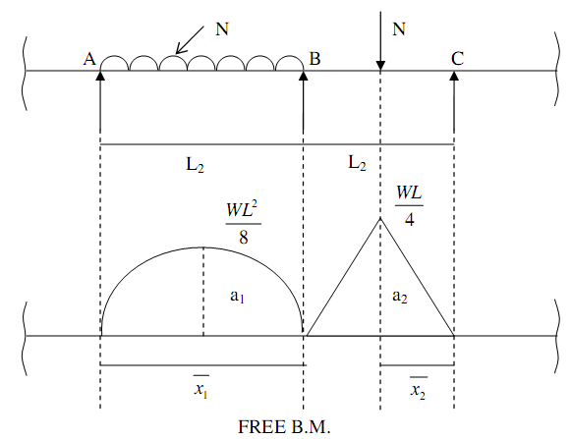
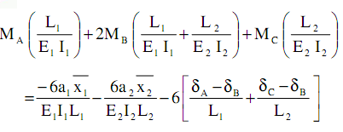
The above equation is called generalized 3-moments Equation.
MA, MB and MC are support moments E1, E2 → Young’s modulus of Elasticity of 2
Spans.

I1, I2 → M O I of 2 spans,

a1, a2 → Areas of free B.M.D.

1 2 x and x → Distance of free B.M.D. from the end supports, or outer supports.
(A and C)

δA, δB and δC → are sinking or settlements of support from their initial position.
Normally Young’s modulus of Elasticity will be same throughout than the
Equation reduces to
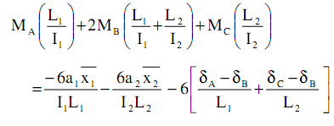
If the supports are rigid then A = B = C = 0
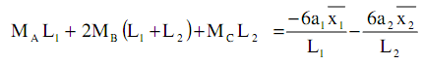
Note:

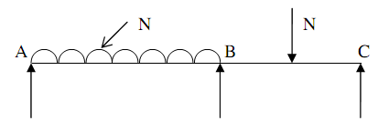
If the end supports are simple supports then M_{A} = M_{C} = 0.

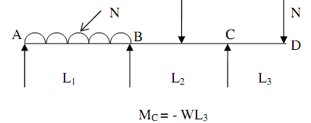
If three is overhang portion then support moment near the overhang can be
Computed directly.

3.
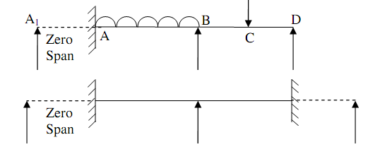
If the end supports are fixed assume an extended span of zero length and apply
3- Moment equation.
NOTE:
i)
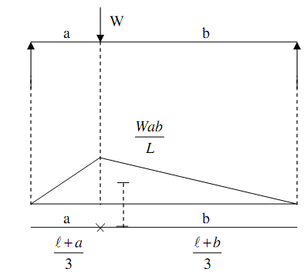
In this case centroid lies as shown in the figure.
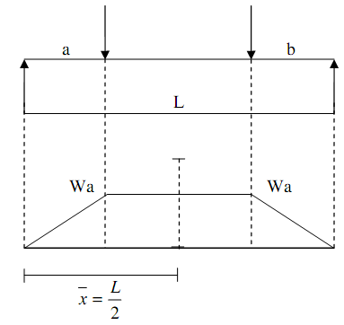
Observation Table:
Section type | Types  of loads | Length of member  (L) | Breadth(b) | Depth(d) | Weight  (W) | At a distance from section ‘X’ | Bending Moment  (Knm) | S.F  (Kn) | Deflection(Delta)
continuo’s  beams | Two Equal Spans – Uniform Load on One Span
Two Equal Spans – Concentrated Load at Center
of One Span
Two Equal Spans – Concentrated Load at Any
Point
 | Two Equal Spans – Uniformly Distributed Load
Two Equal Spans – Two Equal Concentrated Loads
Symmetrically Placed
 | Two Unequal Spans – Uniformly Distributed Load
Two Unequal Spans – Concentrated Load on Each
Span Symmetrically Placed

Output:
1. Bending moment________ (Knm)
2. Shear Force_________ (KN)
3 Deflections_________ (Yc)
References:
1. Theory of Structures volume: 1 by S.P.Guptha and G.S.Pandit
2. Reference taken from N.D.S.

PART – 2
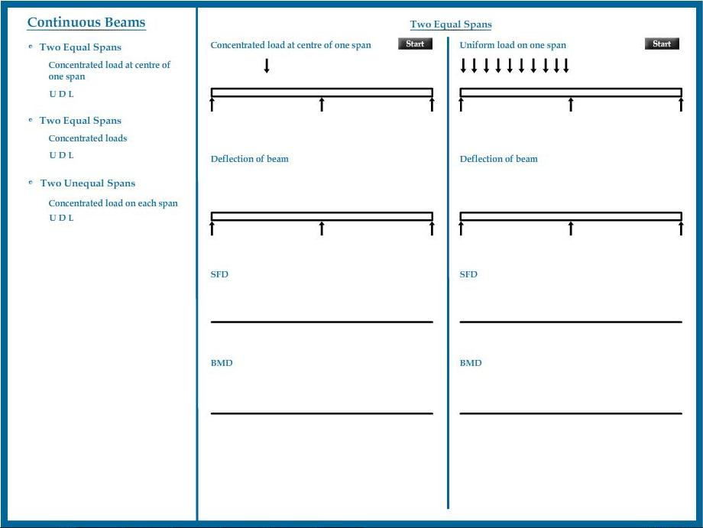
ANIMATION STEPS

PART – 3
VIRTUAL LAB FRAME

